Kimberley Ellis
14a St. John’s Parade, Sidcup High Street, Sidcup DA14 6ES
kimberleyellis1994@hotmail.co.uk
07999 853 990
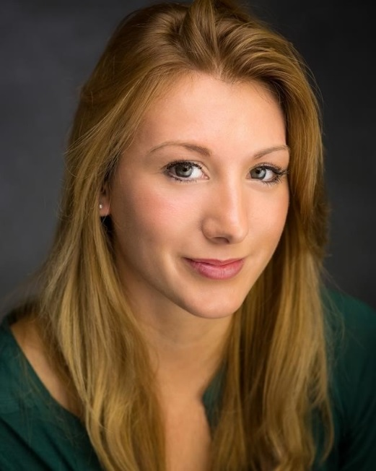
5’5”

Stormy Grey

Brown to Blonde Ombre

Caucasian

A00447353

4939-9081-2796

Care of Spotlight

Height:

Eye colour:

Hair colour:

Ethnicity:

Equity number:

Spotlight Number:

Agent:

Training
American Theatre Arts B.A. at Rose Bruford College 2015-2017
Theatre and Musical Theatre at University of the Arts Philadelphia September 2015- December 2015

Experience at College

Role | Play | Director
Glenna  Alex/Phoebe  Jessica | The Blue Hour  On Us  This is Our Youth | Steven Dykes  Chris Parks  Fraser Murray

Experience outside of College

Role | Play | Director
Mariette  Councillor | The Darling Buds of May  Fugee | Erica Elson  Jo Halstead

Skills
Native Home county’s accent, English (RP), American New York, American West Coast, American Midwest (RP). Full clean Car License, Horse riding , swimming (Breast stroke, Front Crawl and Back Crawl), Acrobatic Gymnastics (basic), Tampolining ( Award 10), Ballet (Intermediate and en pointe), Tap (Intermediate), Jazz (Intermediate), stage combat (basic knife and unarmed training), basic singing skills (mezzo soprano)

07999 853 990
Kimberleyellis1994@hotmail.co.uk

